Execution Context

JS engine sees the bracket of function, it knows it is for function, it creates something called execution context

Eg: sayMyName(), fineName() etc.

The base execution context that is run is actually called Global execution context.

Initially JS engine first creates global() then on top of them are execution context

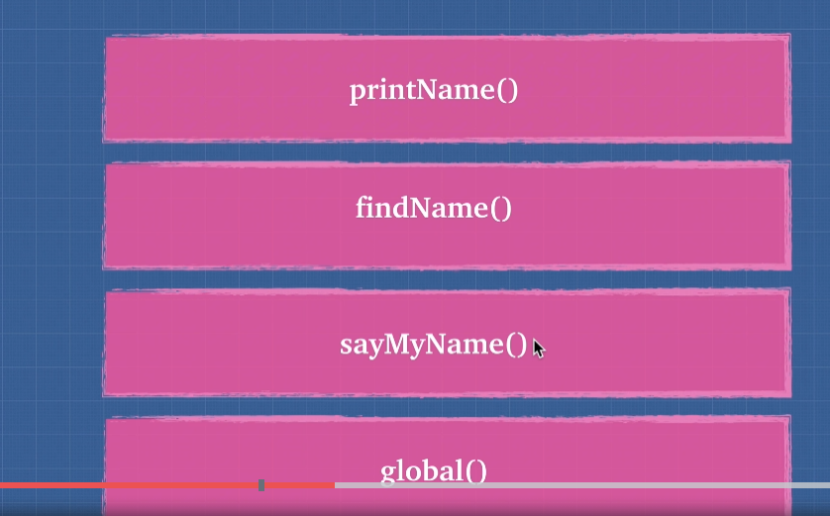

Whenever code is run in JS, it is run inside execution context. Global execution object gives you two things:

1. Global object (In browser is the Window object)
2. this keyword

To this global object, we can assign variables.

Lexical Environment

Lexical environment is simply where you write something. For example, the function we write is one universe. sayMyName is in universe of global. Every time a function is created, it creates a universe for it.

The very first lexical environment is global.

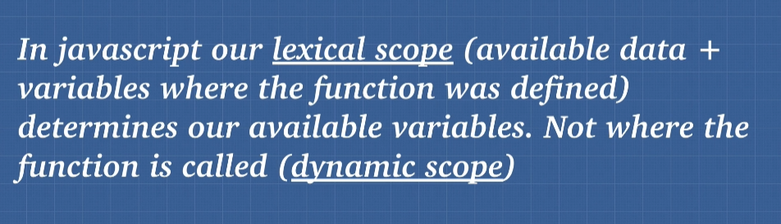

Hoisting

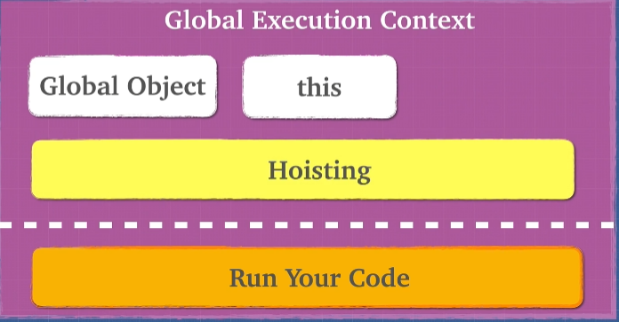

Hoisting is behaviour of moving variables or functions declaration to the top of their respective environments during compilation process